____________________________
Operation Manual

VEUDx Experiment Editor

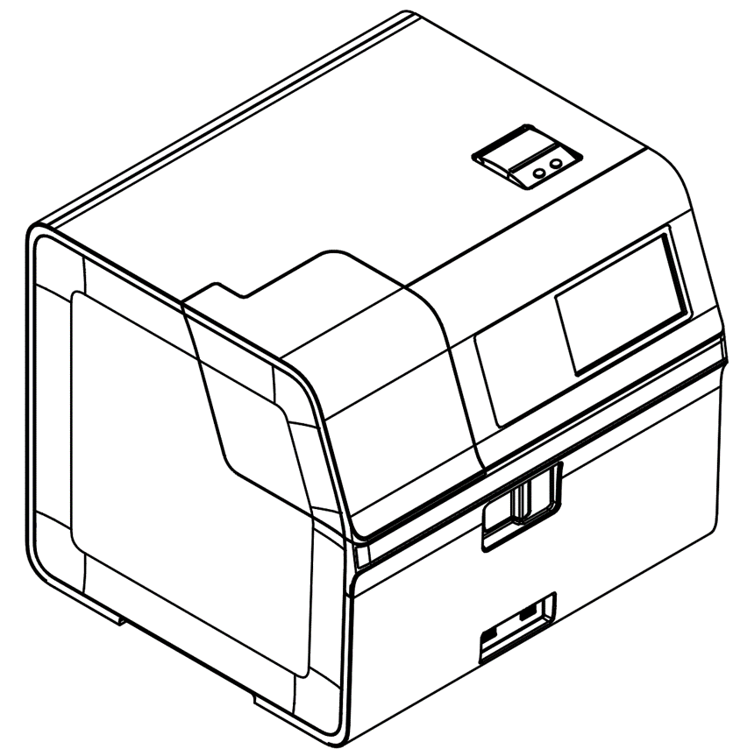

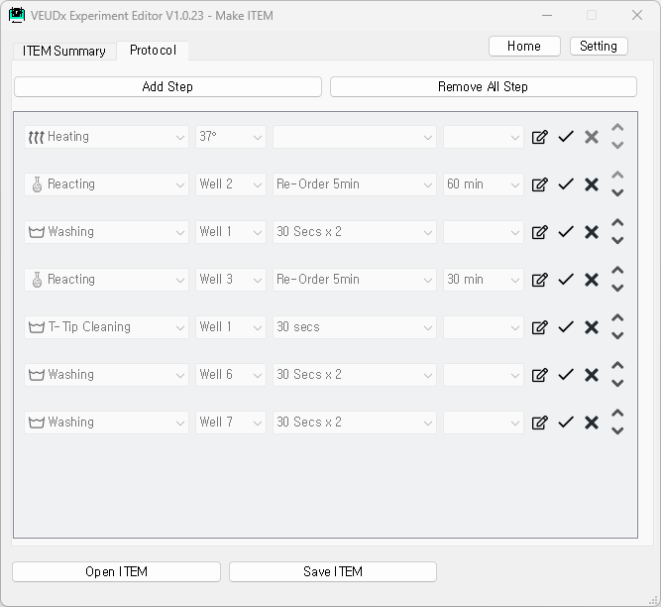

UM-VEUDx-1.0

Index
1. Installation 3
2. Term definition 5
2.1 ITEM 5
2.2 LOT 5
2.3 QC Material LOT 5
3. Start 6
3.1 Start screen 6
4. Make ITEM 6
4.1 ITEM creation start screen 6
4.2 Edit ITEM Summary 8
4.3 Edit Protocol 10
4.4 Save ITEM and Installation 11
5. Make LOT 13
5.1 Select ITEM file 13
5.2 Make LOT 13
6. Make QC Material LOT 17
6.1 Select ITEM file 17
6.2 Make QC Material LOT 17
6. Settings 19
6.1 Open Settings 19
6.2 Unit 19
6.3 Development menu 19

1. Installation
 | 1.1 Installation
1.1.1 Execution | Execute VEUDx Experiment Editor Setup V1.x.x.exe on PC.
1.1.2 Language selection | Choose the language you want to use  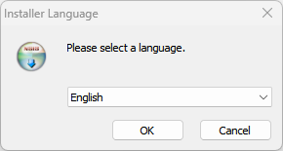
1.1.3 Start installation | Check the contents and click ‘Next’.  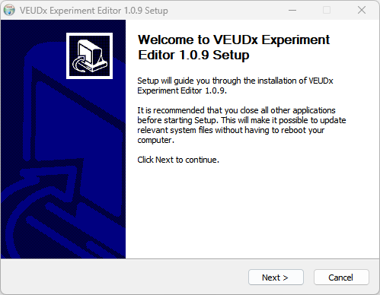
1.1.4 Check License | Read the license agreement and click ‘I Agree’.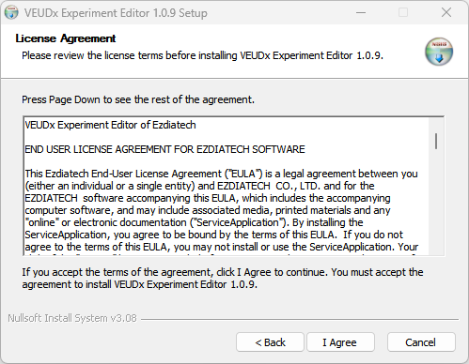
1.1.5 Installation location | Check the installation path and click ‘Install’.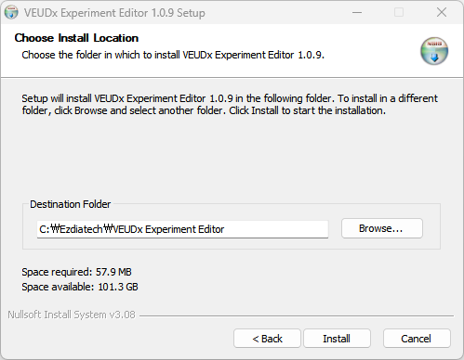
1.1.6 Installation  completion | Check to run the program and click ‘Finish’.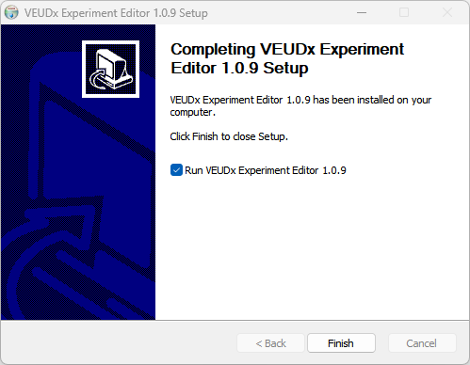

2. Term definition
 | 2.1 ITEM
2.1.1 ITEM | ITEM consists of ITEM name( ex) TBI, Neurology ), Marker name, Pixel Cut, Experiment Protocol, etc.
2.1.2 Protocol | Protocol is a collection of experimental procedures (Steps).
2.1.3 Step | This is the procedure for each well. (ex) Well 6 Washing 1 min )
2.1.3 ITEM file | ITEM File is created as VEUDxITEM_ITEM_name.zip file.  (ex, VEUDxITEM_TBI.zip )
 | 2.2 LOT
2.1.1 LOT | Depending on the produced LOT, it consists of Made Date, Serial, Expire Date, etc. An ITEM file is required to create a LOT.
2.1.2 LOT file | A LOT XML file that stores LOT information and a Barcode PDF file are created.  Ex)  VEUDxLOT_TBI_EZTB22111601.xml  VEUDxLOT_TBI_EZTB22111601_BarCode.pdf
 | 2.3 QC Material LOT
2.3.1 QC Material  LOT | Depending on the produced QC Material LOT, it consists of Made Date, Serial, Expire Date, etc. An ITEM file is required to create a QC Material LOT.
2.3.2 QC Material LOT file | QC Material LOT XML file that stores LOT information and a Barcode PDF file are created.  Ex)  VEUDx_QC_LOT_TBI-assay_230921001.xml  VEUDx_QC_LOT_TBI_230921001_BarCode.pdf

3. Start
 | 3.1 Start screen
3.1.1 Start screen | On the start screen, you can select ‘Make ITEM’, ‘Make LOT’, ‘Make QC Material LOT’ or ‘SW Manual’.  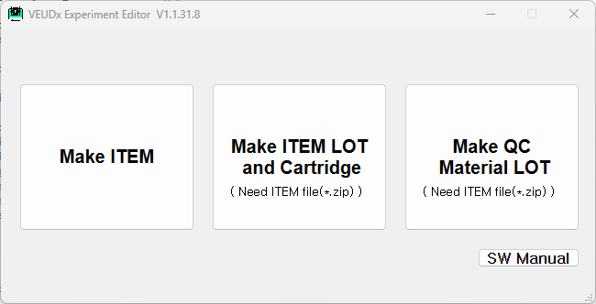

4. Make ITEM
 | 4.1 ITEM creation start screen
4.1.1 Start  screen | ITEM Open, save and edit are possible.  - In the ITEM Summary tab, you can edit the item name, maker name by RSMP length, unit, CutOff, QC High/Low Range, QC Replication, pixel cut, experiment time, Dilution Factor, Fluorescence Exposure Time, Optical photography only, etc.  - You can edit steps in the Protocol tab  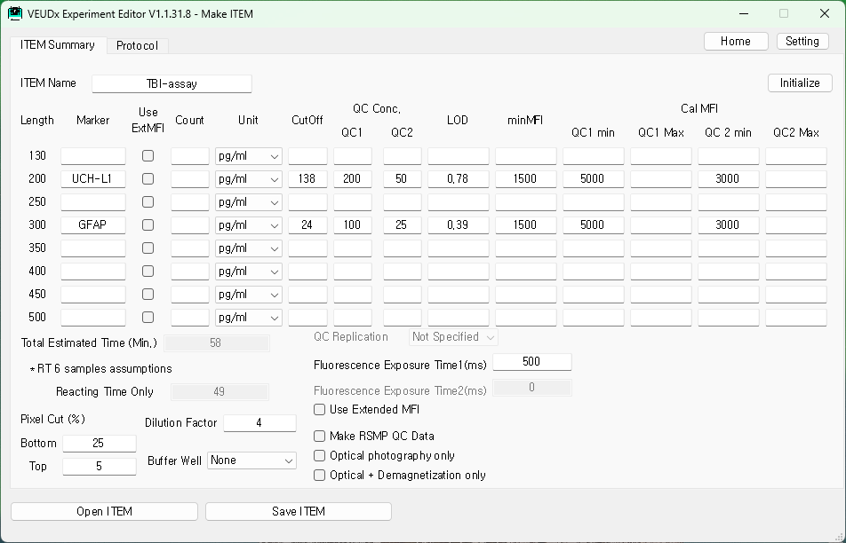
   | - You must input information about the name, unit, and RSMP Length of the markers to be used for the item.  - Based on the input information, the fluorescence image is detected by RSMP Length and the result is calculated.
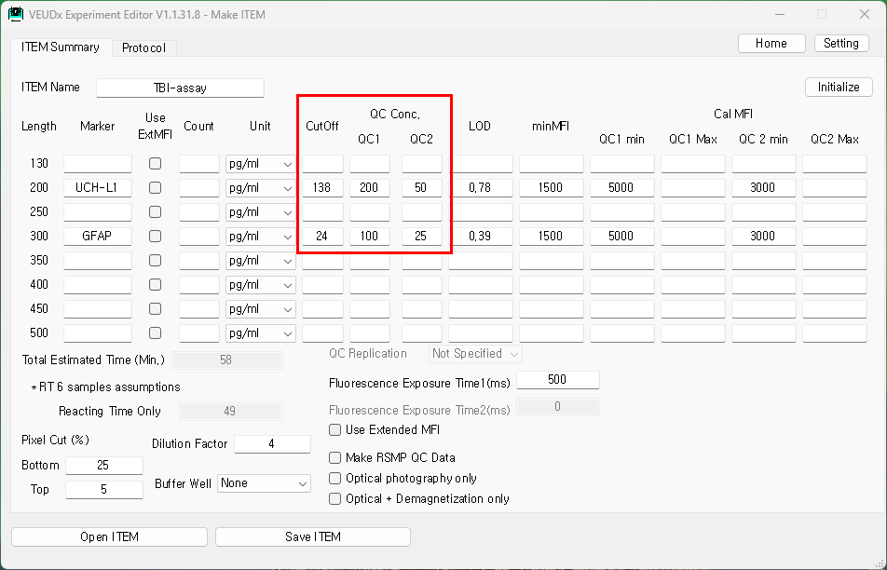

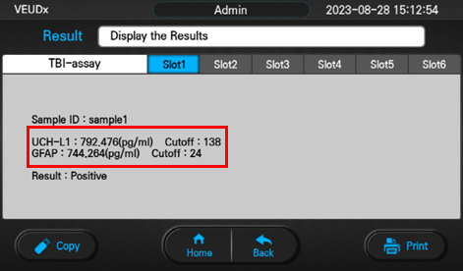
<VEUDx Analysis Result Screen>

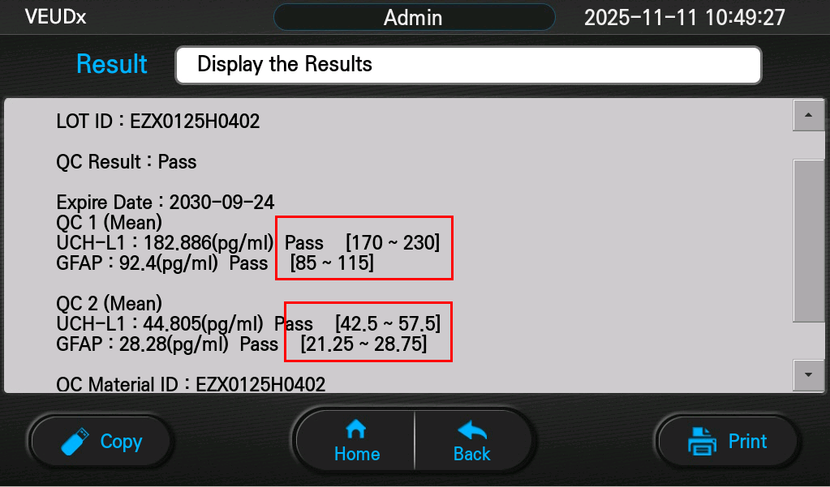
(Plus or minus 15% based on the center)
<VEUDx QC Result Screen>
 | 4.2 Edit ITEM Summary
4.2.1 Open  ITEM | Press the “Open ITEM” button to select the previously created ITEM file.  ITEM files are in *.zip. (ex, VEUDxITEM_TBI.zip )
4.2.2 Edit  ITEM  Summary | Editable below items  - Item name  - Marker name used by RSMP length  - Unit used by RSMP length  - CutOff for Result(Positive/Negative)  - QC High/Low Range  - Pixel Cut Bottom, Top (%)  Remove noise caused by saturation when obtaining MFI.  Defaults to Bottom 25% Top 5%.  - Dilution Factor  The calculated concentration value is multiplied by the 'dilution factor' value.  - Fluorescence Exposure Time  The default value of Fluorescence Exposure is 500ms.(1~1000)  If the MFI value of the item you are using is high or low, adjust the  ‘Fluorescence Exposure’ value.  (High MFI values can affect fluorescence saturation)  - Optical photography only  Check if you only want to image capture and Detecting  (RSMP is demagnetized)  - Optical + Demagnetization only  Check if you only want to image capture and Detecting  (RSMP is not demagnetized)  (RSMP should be in imaging well 8)  - Make RSMP QC Data  If you select the ‘Make RSMP QC Data’ Option, you can acquire MFI, CV(%) values for each RSMP and for the entire RSMP.  (Used to check RSMP Ab coupling QC status)  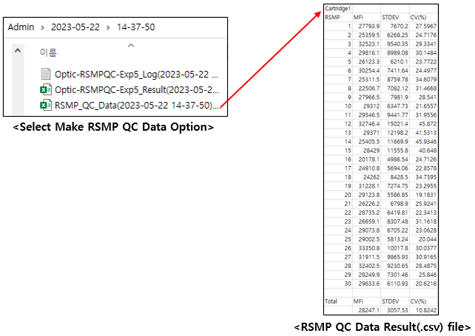
  If you want to use a different concentration unit, you can add a concentration unit in ‘Setting’
 | 4.3 Edit Protocol
4.3.1 Protocol tab | If you select the Protocol tab, you can edit the Step.  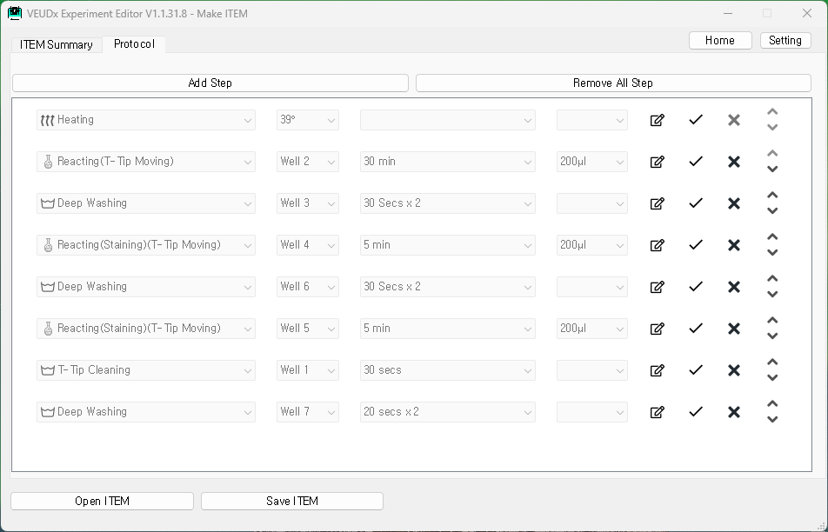
4.3.2 Add  Step | Click the “Add Step” box at the top and add an item.  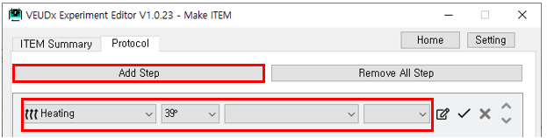  - Selection by Category  .Heating : 30°/ 35° / 37° / 38° / 39° / X / RT selectable  .Reacting(Staining)(T-Tip Moving)  : Well2~7 / Time(3 min, 5 min) / T-Tip depth (150μl, 200μl) selectable  *Shuffle every 2min  .Reacting(T-Tip Moving)  : Well2~7 / Time (1~480 min) / T-Tip depth (150μl, 200μl) selectable  *Shuffle every 5min  .Reacting Shuffle(T-Tip Moving)  : Well2~7 / Shuffle Time (1,2,5 min) / Time( 1~60 )  .Reacting(Staining)(M-Bar Moving) (Not Recommend)  : Well2~7 / Time (3 min, 5 min) / T-Tip depth (150μl, 200μl) selectable  .Reacting(M-Bar Moving) (Not Recommend)  : Well2~7 / Time (1~480 min) / T-Tip depth (150μl, 200μl) selectable  .Washing : Well1~7 / Time ( 10, 20, 30 secs, 1 min, 30 secs x4 ) selectable  .Deep Washing : Well1~7 / Time ( 20 secs, 30 secs, 20 secs x 2, 1 min,  30 secsX2, 1 min+30 secs X 3) selectable  .T-Tip Cleaning : Well1~7 / Time ( 20, 30, 45, 90 secs) selectable  ‘T-tip Cleaning’ use after Staining Reaction to prevent PE buffer from remaining on the T-Tip into the Imaging Well.  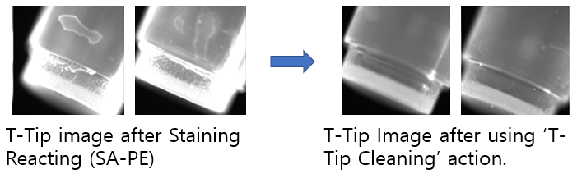
   | Heating can be selected only once and must be located only in the first step.
- Edit Step | -  : Change edit Step mode  -  : Save Step  -  : Delete Step  - : Change Step Order
 | 4.4 Save ITEM and Installation
4.4.1 Save  ITEM to PC | Click the “Save ITEM” button to create an ITEM zip file.  *For how to save only protocol (script) for development reference, refer to the setting section.
4.4.2 ITEM  installation  on VEUDx  quipment | 1. Copy the ITEM file created above to an external USB memory  2. Run VEUDx equipment  3. Admin Login (Initial Admin Password: 0000)  4. Click Settings  5. Click Information  6. Click Item  7. Mounting on an external USB memory device  8. Select Update  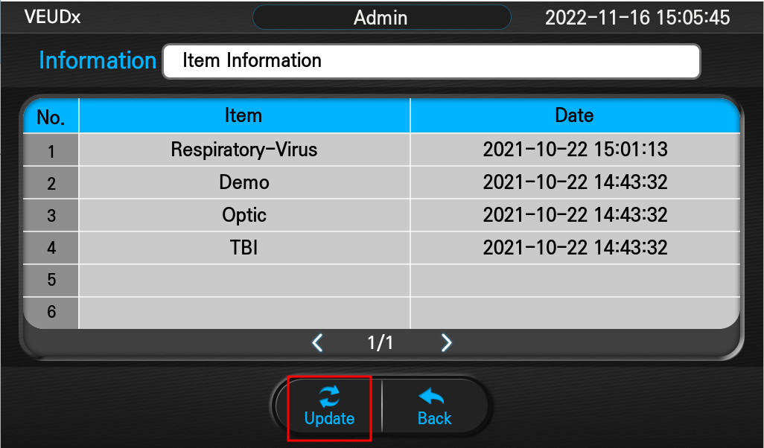  When you press “Update” button, you can check the updateable ITEM list.  (Update file must be placed in the USB Root folder)  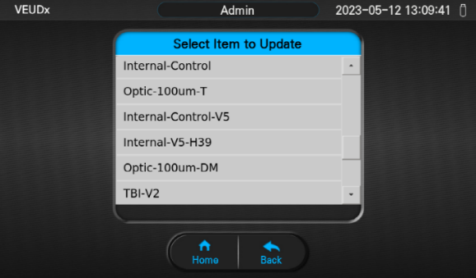  9. Select ITEM to update  10. ITEM update complete  11. Restart after shutting down the equipment
  When you press each item, you can check detailed information such as each marker name and unit.
  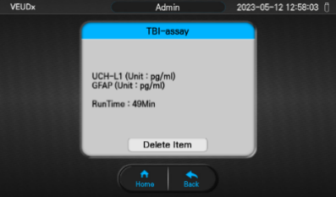

5. Make LOT
 | 5.1 Select ITEM file
5.1.1 Select  ITEM file | Select ITEM file to make LOT.  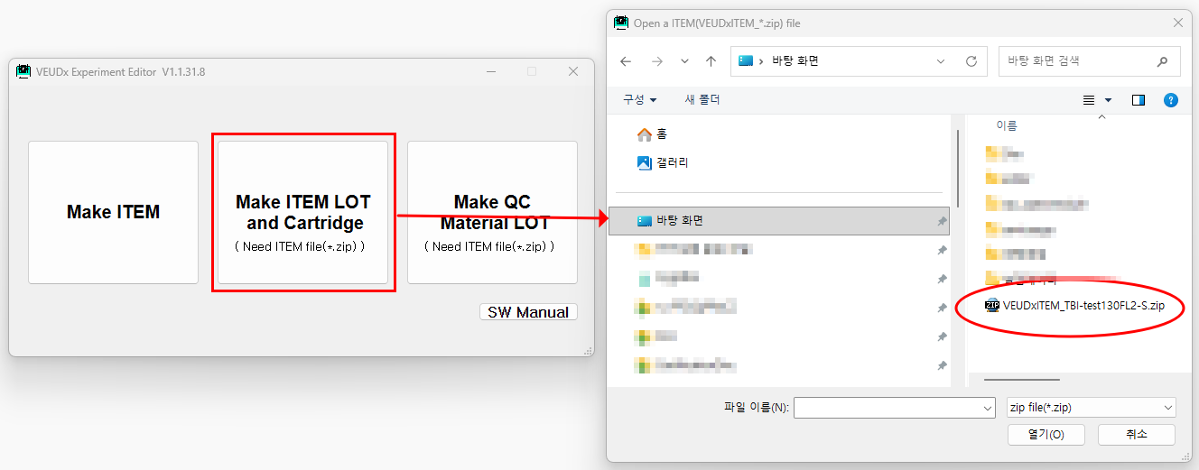
 | 5.2 Make LOT
5.2.1 Start | 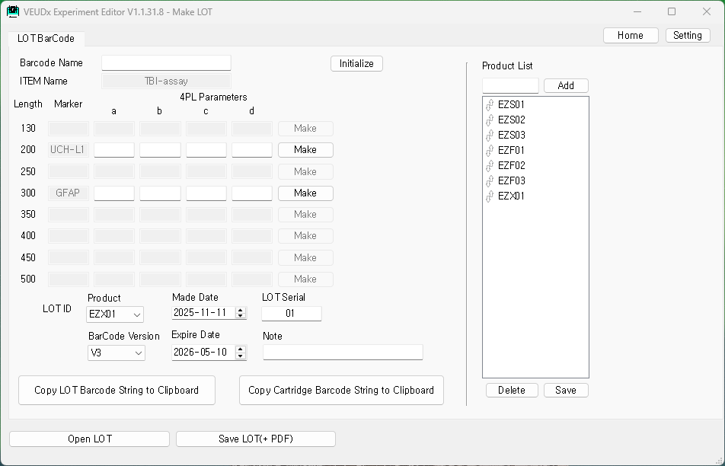  The ITEM name and Marker name read from the ITEM file are displayed.
5.2.2 Enter LOT  information | - 4PL Parameters (a, b, c, d)  - LOT creation date  - LOT Serial  - LOT Expire Date can be entered.  *Barcode Name, Note can be used as a reference.
5.2.3 Calculate  4PL Parameters | - Select “Make” button for each Maker.  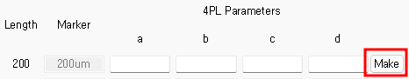  - 4PL calculation screen  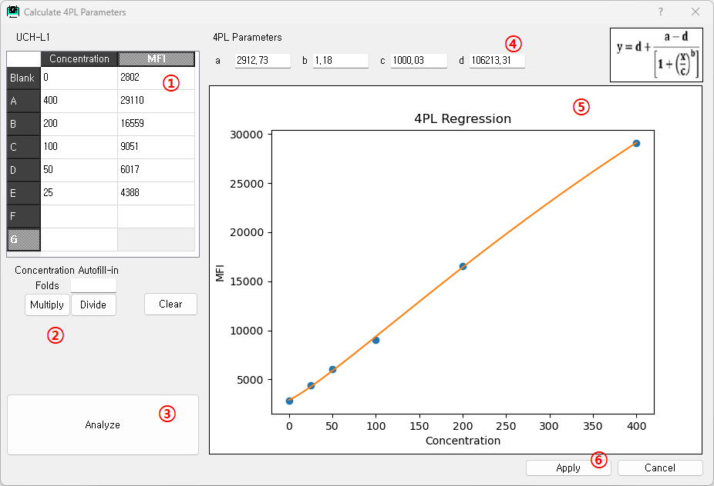  - Concentration, MFI input  (Copy/Paste available in Excel/Notepad)  - Automatically multiply and divide as much as Folds(multiples) based on A concentration  - Calculate 4PL parameters and graphs according to the input  concentration and MFI values  - Calculated graph  - Apply to the LOT edit screen by selecting “Apply” button  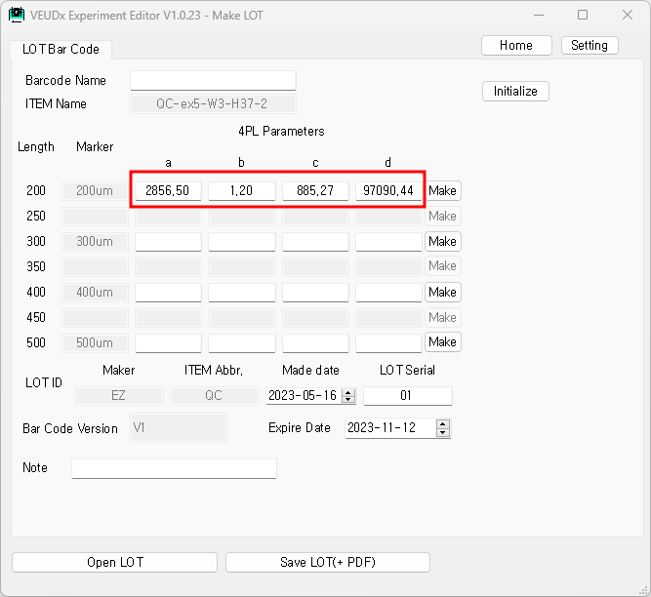
5.2.4 Copy  Barcode string  to Clipboard | When you press the “Copy LOT Barcode string to Clipboard” Button, the LOT Barcode string below will be copied to the clipboard.  Ex)”VEUDx-L/V3/230927001/TBI-V2/240325/1_a2_b3_c4_d5_x65535_n0/3_a6_b7_c8_d9_x65535_n0”  When you press the “Copy Cartridge Barcode string to Clipboard” Button, the Cartridge Barcode string below is copied to the clipboard.  ex)”VEUDx-C/V3/230927001”
5.2.3 Save LOT | Click the “Save LOT(+PDF)” button  Two LOT XML files and Barcode PDF files are created.  - LOT XML file (ex, VEUDxLOT_TBI_EZTB22111601.xml) Used to save work  When using VEUDx equipment, it can be used when there is no Barcode Reader equipment.  - Barcode PDF file (ex, VEUDxLOT_TBI_EZTB22111601_BarCode.pdf)  It is used for reading VEUDx equipment LOT/Scrip Barcode by printing it out on paper.  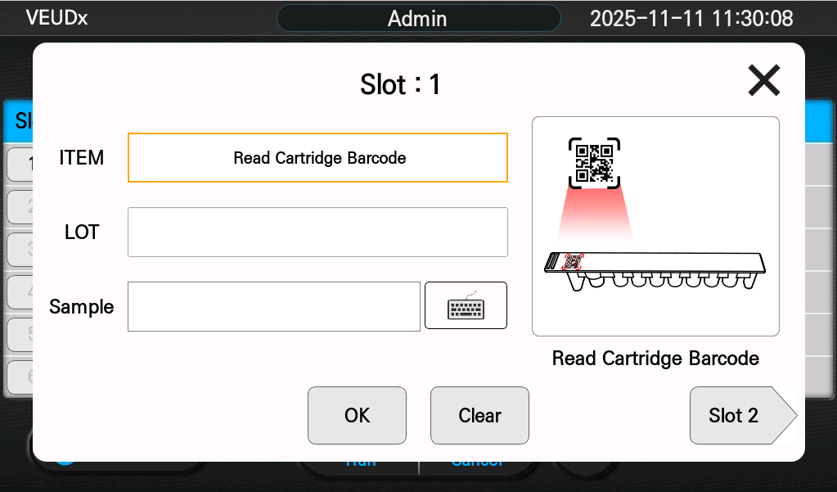  < VEUDx equipment LOT reading screen >  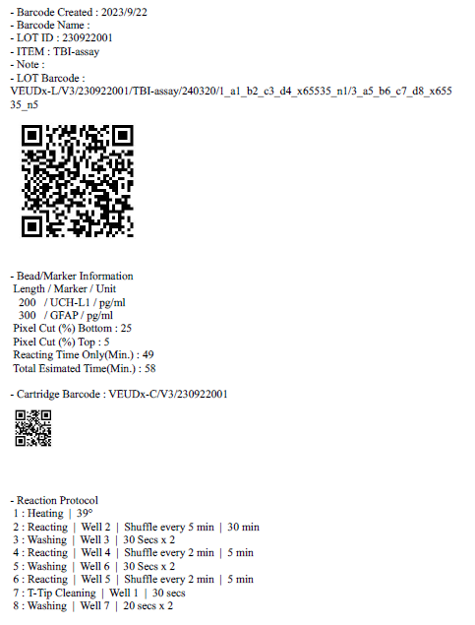  < PDF file for LOT Barcode output >
5.2.4 Open LOT | Editing is possible by selecting the saved LOT XML by pressing the “Open LOT” button.

6. Make QC Material LOT
 | 6.1 Select ITEM file
6.1.1 Select  ITEM file | Select ITEM file to make QC Material LOT.  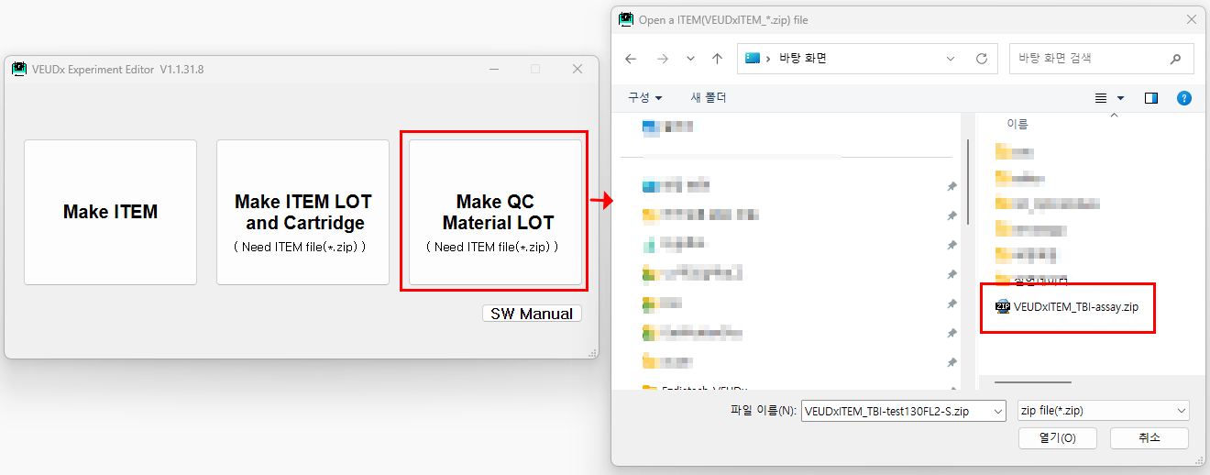
 | 6.2 Make QC Material LOT
6.2.1 Start | 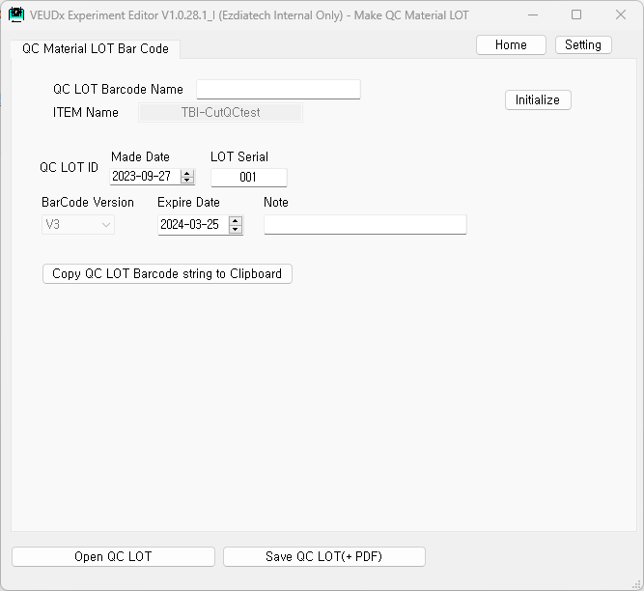  The ITEM name read from the ITEM file are displayed.
6.2.2 Enter QC Material LOT  information | - QC Material LOT creation date  - QC Material LOT Serial  - QC Material LOT Expire Date can be entered.  *Barcode Name, Note can be used as a reference.
6.2.3 Copy  Barcode string  to Clipboard | When you press the “Copy QC LOT Barcode string to Clipboard” Button, the QC LOT Barcode string below will be copied to the clipboard.  Ex)” VEUDx-Q/V3/230927001/TBI-CutQCtest/240325”
6.2.4 Save QC  Material LOT | Click the “Save QC LOT(+PDF)” button  Two QC LOT XML files and Barcode PDF files are created.  - QC Material LOT XML file (ex, VEUDx_QC_LOT_TBI-assay_230922001.xml) used to save work  - QC Material Barcode PDF file  (ex, VEUDx_QC_LOT_TBI-assay_230922001_BarCode.pdf)  It is used for reading VEUDx equipment QC Material Barcode by printing it out on paper.  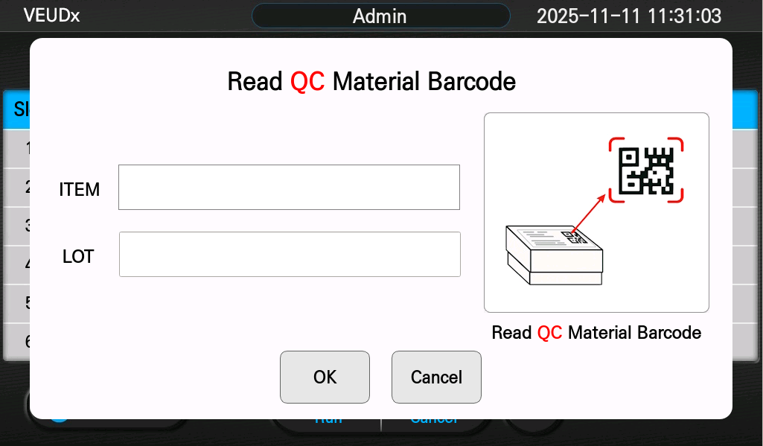  < VEUDx equipment QC Material LOT reading screen >  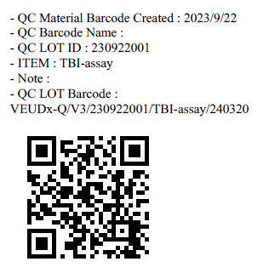  < PDF file for QC Material LOT Barcode output >
6.2.5 Open QC Material LOT | Editing is possible by selecting the saved LOT XML by pressing the “Open QC LOT” button.

6. Settings
 | 6.1 Open Settings
6.1.1 Open  Settings | ‘Press the ‘Settings’ button.  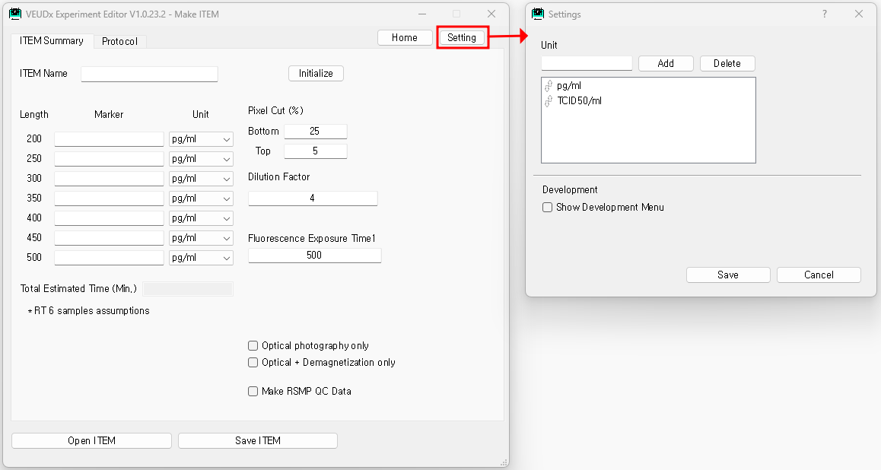
 | 6.2 Unit
6.2.1 Unit | Units to be displayed in the Unit Combo List of the ITEM Summary tab can be edited.  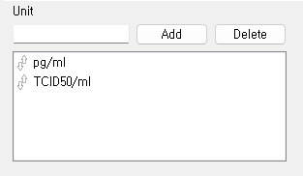
 | 6.3 Development menu
6.3.1 Development  menu | If you select the development menu, you can open/save only the protocol and display comments for analysis.  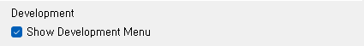
 | 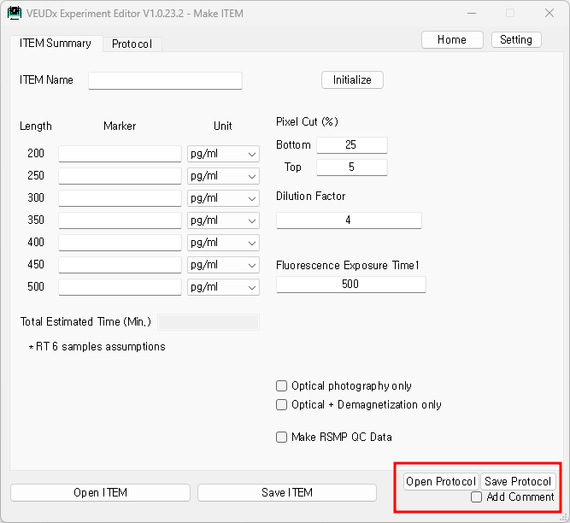
6.4.2 Save  protocol file | If you press the ‘Save Protocol’ button, only the Protocol (Script) file can be saved separately.  This is a development file and cannot be installed on a machine.  When “Add Comment”, comments are displayed on the Protocol (Script).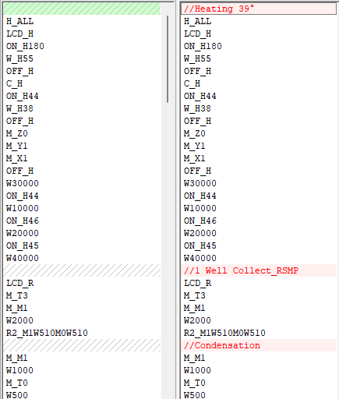  < Protocol display according to annotation options >

